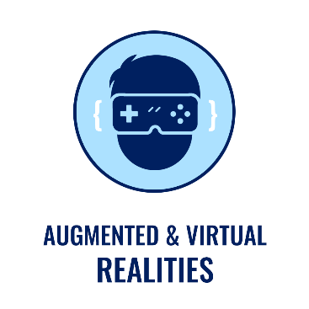Individual Assignment 1a:   
Proposal of WebXR Application

Billiard Ball

05111740000196- Jihad Rausyan Fiqrussalam

## Application Overview

Billiard Ball is simple billiard video game based on A-FRAME, Web Framework for making VR Application. In this game, player will be given a white ball for shooting another ball into six holes that spreads in the billiard table, four on each corner and two on the long sides. If the white ball suddenly goes into those holes, player can retrieve it with pressing the button that available on the short side of billiard table. The game is finish when the player makes those ball, excluding the white ball, goes into holes.

## Sketch of XR World

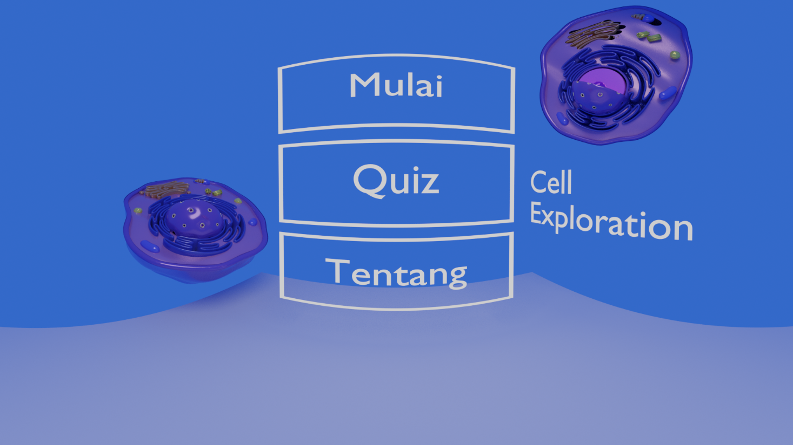

Figure 1. Menu Screen

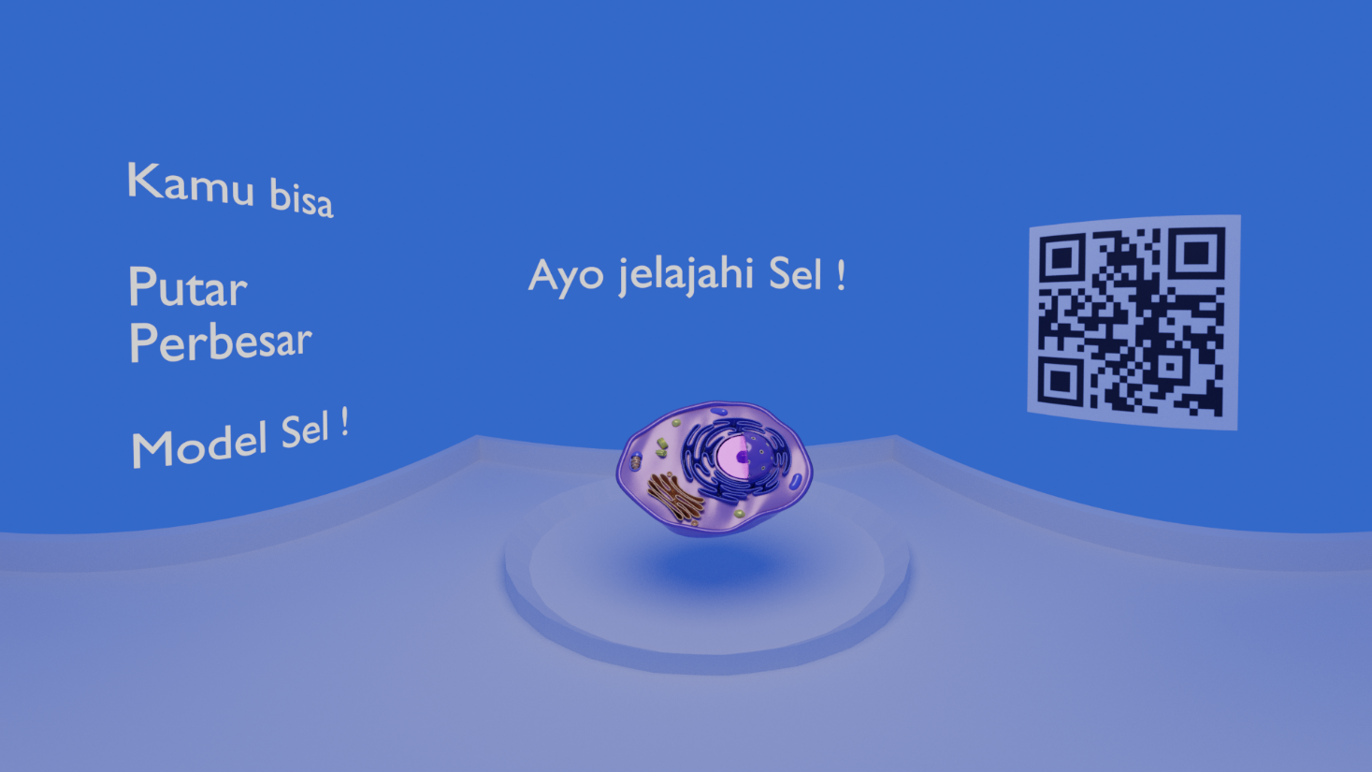

Figure 2. Explore the Cell Screen



Figure 3. The Quiz screen



Figure 4. Quiz results screen



Figure 5. Tentang screen

## Sketch of Interaction

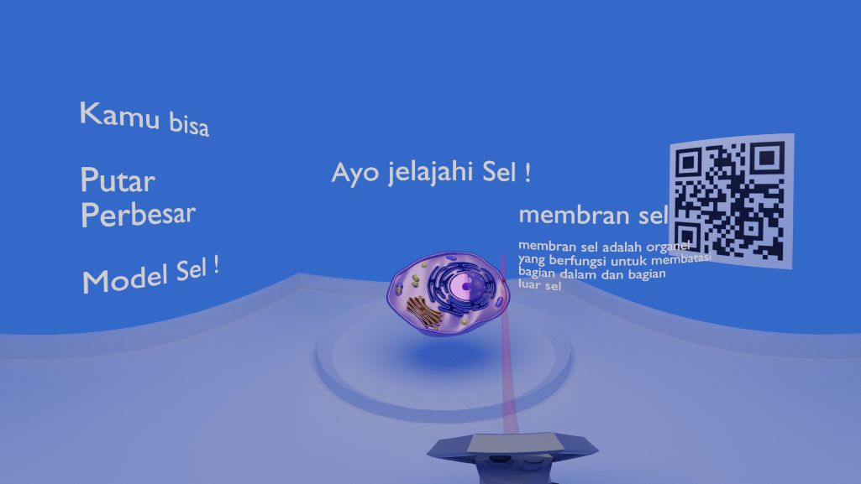 Figure 6. Rotate the Cell Model

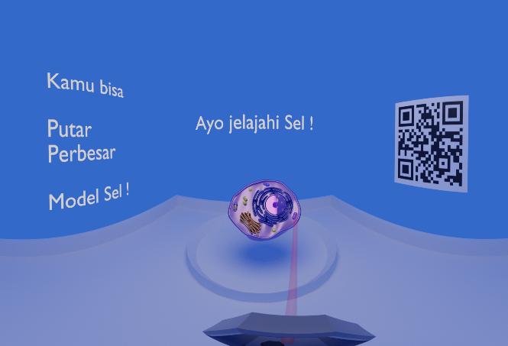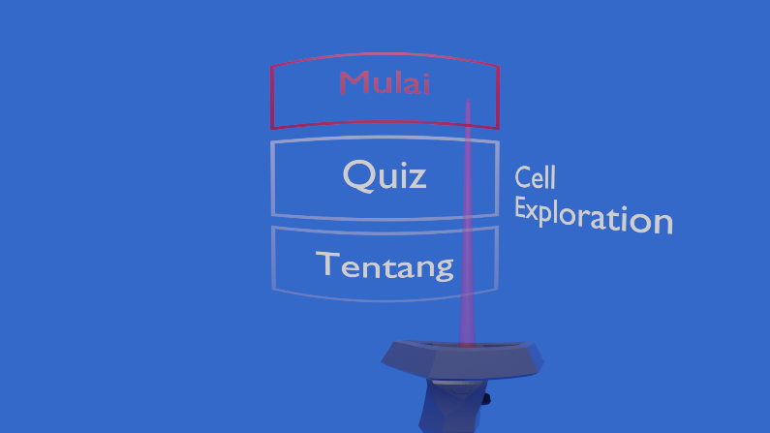*Figure 7. Point the Cell Organelle to read the explanation*

*Figure 8. Click the “Mulai” Button to change scene to Exploration scene*

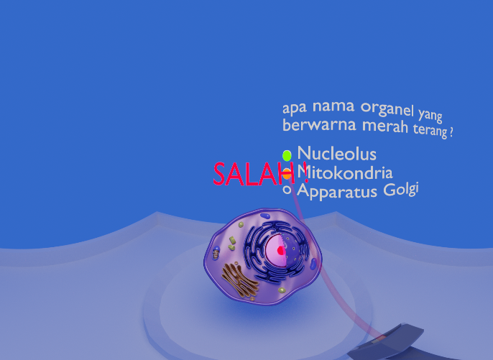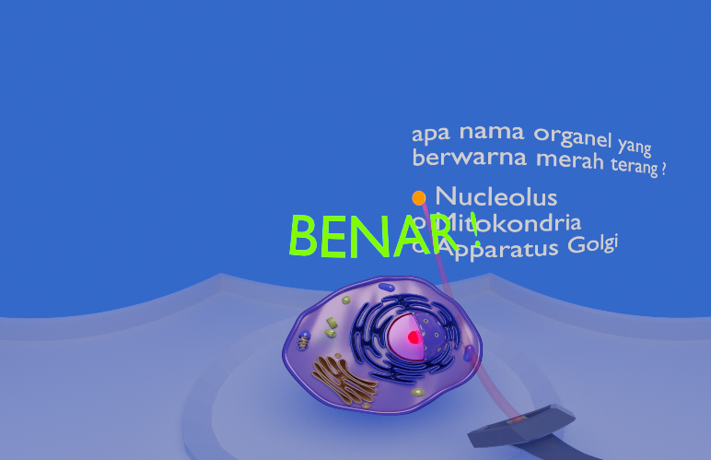*Figure 9. User shown the result after choosing the answer*

## Object Dynamics

### Local Variables

Cell Model

* User can rotate it
* User can zoom it
* User can point some part of it to get the explanation

Quizzes

* User can answer the question
* User can see the quiz result
* User can see it choice result (correct /wrong)

### External Variables

MongoDB :

* Questions
* Organelle Explanations